https://mdb.gingrapp.com/front_end/login/email
Go to our Pet Parent Portal via our link above or through our website by clicking “create reservation”
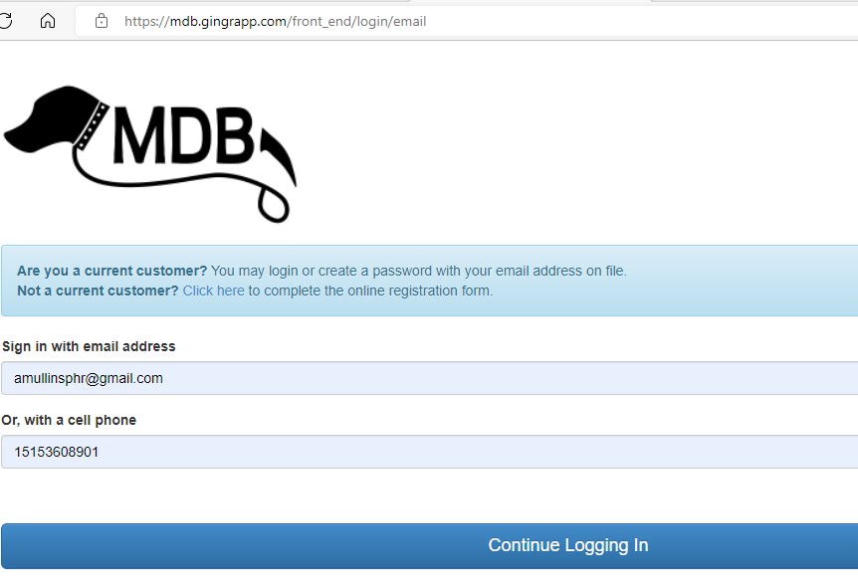
Sign in using your cell phone number and email on file if you are a current customer or “Click Here” if you are new to MDB. You can use the password reset function if you are a current customer who has never logged in before. The system will verify you are not a robot and then you will get to your Dashboard.
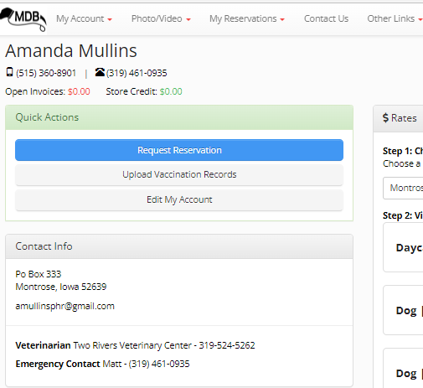
From the Dashboard, you can use the “Quick Actions” menu to create a reservation, upload vaccination records, or edit information in your account. Go to “My Account” to see other options.

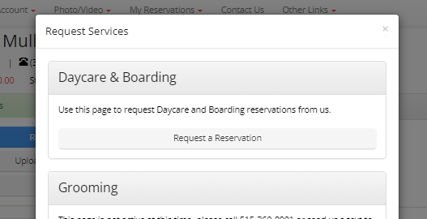
To begin your reservation, click “Daycare & Boarding”. (You can now make requests for grooming through the Portal as well!)
- Select which service TYPE you are requesting (Boarding with Group Play, Boarding no Group Play, Daycare, or Grooming +$5 daycare)
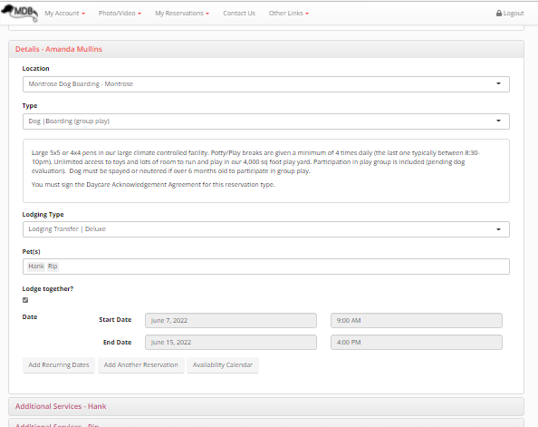
- Select the Lodging (9’x5’ Deluxe is an extra $10/day, Standard is or regular 5x5 or 4x4 kennel)
- Select which pets you want on the reservation and if you want them to share a kennel. If Lodge together is not selected, they will be assigned separate kennels.
- Select your Start Date and Time and your End Date and Time. Please be as accurate as possible since we schedule other reservations in and out according to the times you give.
- You can make a “recurring” reservation (ie: daycare every Tuesday) and additional reservations here as well.
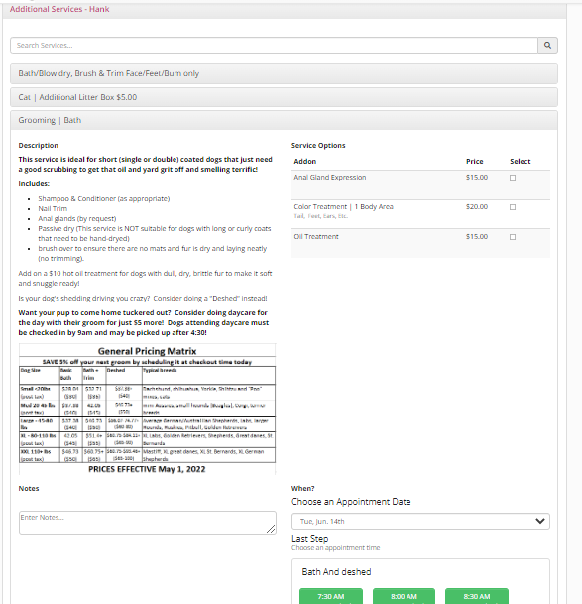
Under “Additional Services” you can also add a Nail Trim, Bath or Full Grooming for your dog while they are boarding or for daycare (subject to availability).
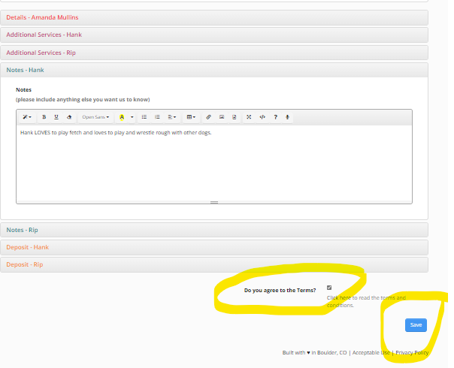
You can make “Notes” for us regarding your dog- this is especially helpful if it is their 1st time staying with us.
It is critical that you click the “agree to the Terms” radio button and click “Save”

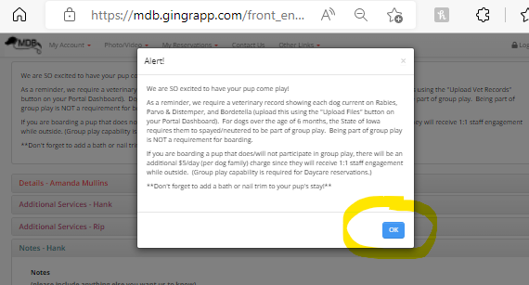

After clicking “Save”, you should get the below Alert box. Click “OK”
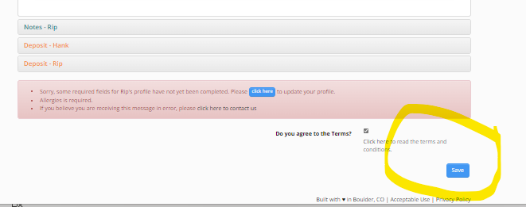
You will then need to click “Save” again. If there is any required information that is incomplete in your profile, the system will require you to complete it before you can save your reservation. Click the “Click Here” message and the system will tell you what information is missing.
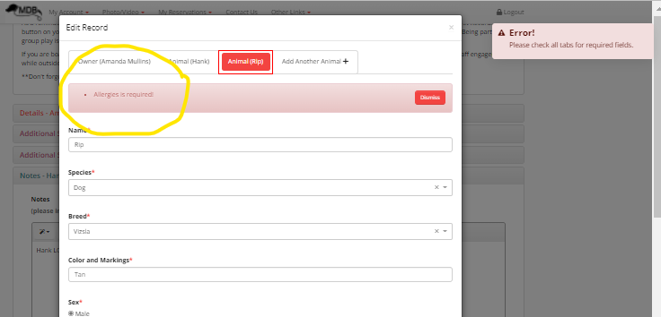

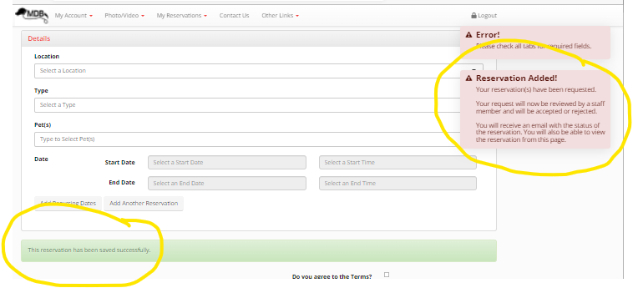
Once the missing information is entered and saved, the reservation will be submitted. You should see the messages circled in yellow below.

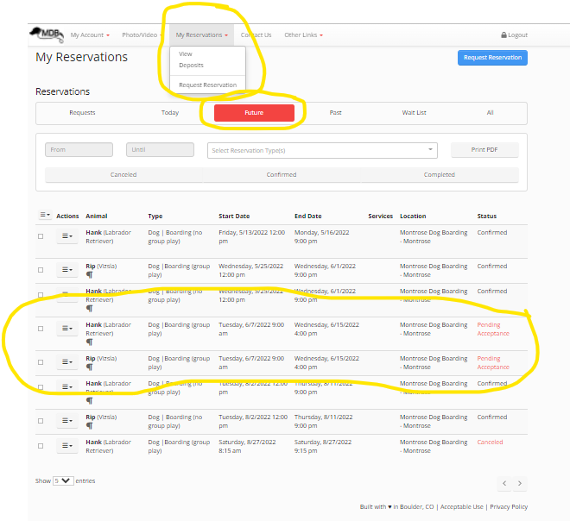
Our staff will receive a notification of your request and review our availability to approve the reservation. You can view Pending reservations and other future reservations from the “My Reservations” tab on your Dashboard. When your request is approved, it will show as “Confirmed” and you will also receive a text message and email confirmation. This typically happens within 12 hours- occasionally longer on weekends.
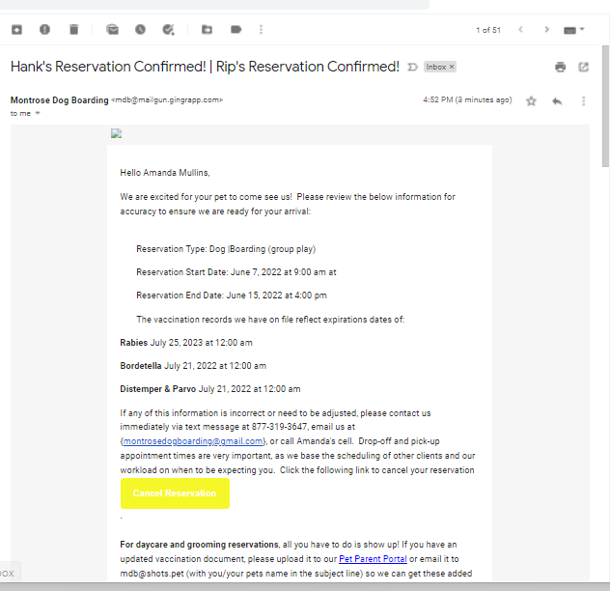
As soon as the reservation is approved by an MDB Team Member, you will receive a text message and email message confirming the start date and time, any needed vaccination documentation, and information on what to bring. If you have a reservation for more than 1 animal, their confirmations will all be in the same email. Keep this email for reference on what to bring for their stay. We’ll send you a reminder as well a day or two prior to their stay.

